The J Marr Group Corporate Social
Responsibility Policy

Incorporating:

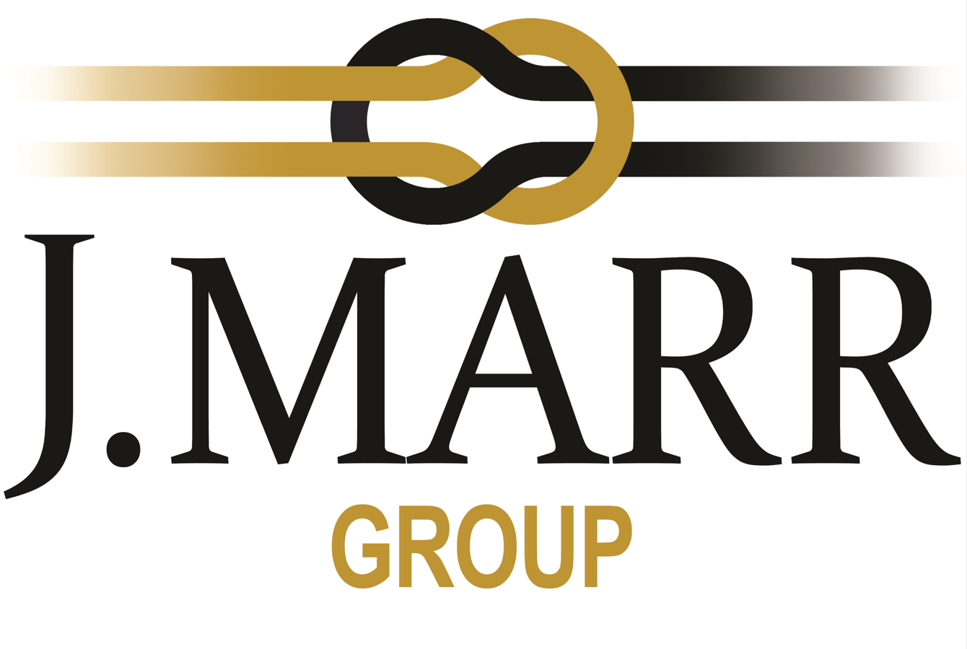

Statement of Intent

The J-Marr Group recognises its obligations to act responsibly, ethically and with integrity in all aspects of our business: Our staff, our customers and our products are empowered by our individual policies covered in this document.

- Customer Focus
- Quality Assurance and Product Requirement
- Environmental and Energy Sustainability and Responsibility
- Ethics and Personnel Responsibility
- Health and Safety
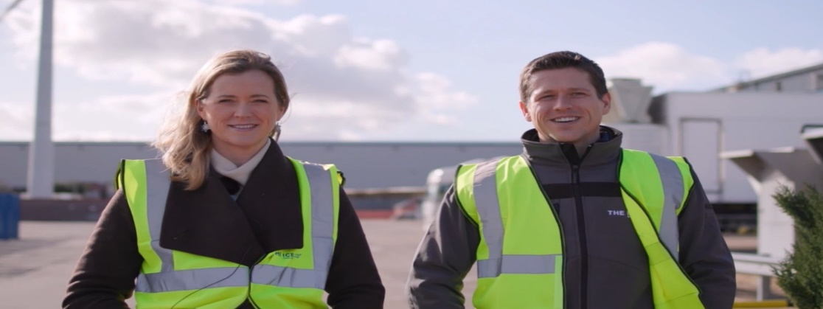

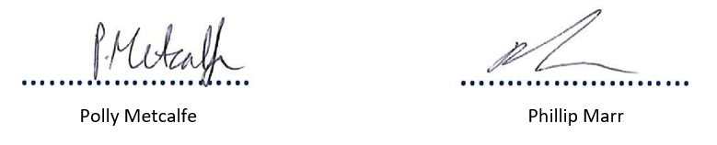
Director | Director
Date: 03/11/2025 | Date: 03/11/2025

Our History

Joseph Marr was the man who started it all, way back in 1860...

He was a young fish and ice merchant and his fishing fleet needed to keep their catch cold whilst at sea so he imported glacial ice. Seeing the growing demand for ice, and being the entrepreneur that he was, he built his first ice factory in 1908 to serve the needs of merchants and fisherman in Fleetwood. Over the year’s ice manufacturing and cold storage developed within the Marr Group and by 1987 ice was being sold in retail stores for consumers.

Now, we use modern, state of the art purification and production techniques to manufacture ice and have a growing network of temperature-controlled storage and distribution sites. We have grown to become Europe’s largest manufacturer of ice, thanks to the hard work of six generations of the Marr family. We are still family owned to this day, with all three members of the Marr family occupying hands on roles in the business. We create, produce, store and distribute our innovative products with the help of our valued team across three UK sites.

Our Vision, Mission and Values.

As a group, we all work towards the same vision, mission and values.

Our Vision

The leading manufacturer of quality ice products and temperature-controlled storage and distribution. With brands that are internationally recognised as the product of choice.

Our Mission

Our mission is to keep the nation cool and refreshed by working with the best retailers, wholesalers and food service suppliers to deliver high quality ice products around the UK and Europe.

Our Values

We INSPIRE through knowledge it’s not just frozen water, you’d be surprised how much there is to know!
We rise to CHALLENGE because anything is possible.
We continue to EVOLVE we used to the best fishing company, now we are the best ice company.
We are PROUD of our company and our people it’s about long-term success over short term gains.
You can DEPEND on us don’t worry, we will sort it…

1. Customer Focus

We are dedicated to consumer enjoyment and to our customer’s success. Product availability and quality service is our ongoing mission. We are committed to responsible and reliable customer communication.

2. Quality Assurance and Product Requirement

We have been committed to quality since 1860. Our products and services are provided to the exacting standards of quality, safety, legality and authenticity expected by our customers. We lead the market through product and process innovation.

3. Sustainability and Environmental Impact

As a family owned and operated business, legacy, innovation and continuous improvement is vital to our success. We believe in taking responsibility for our environmental impact and consistently strive to make our business more efficient and sustainable for the future.

4. Ethics and Personnel Responsibility

We value everybody’s opinions and are passionate about investing in our employees. We are proud of our open honest culture. We fully support the ETI base code, and our goal is to improve the conditions of work for all our valued team members.

5. Health and Safety

We are committed to protecting employees, contractors and others involved in work activities at all times. Our priority is to prevent accidents, injuries and illnesses related to work and ensure everyone is trained on how to stay safe at work.

Detailed Descriptions

1. Customers Focus

We are dedicated to consumer enjoyment and to our customer’s success. Product availability and quality service is our ongoing mission. We are committed to responsible and reliable customer communication.

Our core business strategy is built around consumer enjoyment, customer success, product availability and service via a growing network of cold storage, distribution and manufacturing locations across the UK.

2. Quality Assurance and Product Requirements

We have been committed to quality since 1860. Our products and services are provided to the exacting standards of quality, safety, legality and authenticity expected by our customers. We lead the market through product and process innovation.

Our company is totally committed to providing its customers and ultimately consumers with products and services which have constantly high standards of Safety, Quality, Authenticity and Reliability, complying with all relevant legal requirements. Regular audits of processes are an important part of our quality practices. Our commitment is never to compromise on the safety of any product or service and to be the leading manufacturer of ice products and temperature controlled storage and distribution.

We will do this by:

- Building trust with our customers by providing products and services that match or exceed customer expectations
- Complying with all internal and external food safety, regulatory and quality requirements

We strongly believe that quality is everybody’s responsibility. We continuously challenge ourselves to constantly improve and achieve the highest levels of quality using the quality objectives that we have set. We maintain the same high standards in all areas of the business that we operate and ensure the delivery of high quality products and services through our Quality Management Systems.

Objectives will be reviewed on an annual basis and this will be championed by the Managing Directors of each subsidiary company

3. Sustainability and Environmental Impact

As a family owned and operated business, legacy, innovation and continuous improvement is vital to our success. We believe in taking responsibility for our environmental impact and consistently strive to make our business more efficient and sustainable for the future. Our goal is to be leaders in sustainability in the frozen food industry, being the number one choice for sustainability by our customers, with a fit, healthy and empowered workforce. We source only from others with aligned values and constantly work to seek further improvements which in turn reduce our impact on the environment.

Our three priority areas are: people, process and planet. Implementation is through the company’s sustainability program:

- People: we treat all employees equally, we have a fit and healthy workforce, we empower employees, and their wellbeing is at the forefront of that we do.
- Process: we are the ice brand of choice for our sustainability, we drive waste from our processes and source as sustainably as possible. Improvements in technology, clean energy and sourcing all contribute towards our reduction on our impact on the planet.
- Planet: We support our local community, national charity and world causes that are close to our hearts of our workforce and have a strong focus on the environment.

We believe that sustainability and environmental performance is a shared responsibility and requires the cooperation from all parts of the business.

Objectives will be reviewed on an annual basis and this will be championed by the Managing Directors of each subsidiary company

4. Ethics and Personnel Responsibility

We value everybody’s opinions and are passionate about investing in our employees. We are proud of our open honest culture. We fully support the ETI base code, and our goal is to improve the conditions of work for all our valued team members.

Our success is based on our people. We treat each other with respect and dignity and expect everyone to promote a sense of personal responsibility. We encourage open, honest evaluation and expect our team to challenge the norm and investigate how things can be done better. We provide equal opportunities for recruitment, development and advancement. We do not tolerate any form of harassment or discrimination. We seek to continually improve our workers’ experience.

Objectives will be reviewed on an annual basis and this will be championed by the Managing Directors of each subsidiary company;

5. Health and Safety

We are committed to protecting employees, contractors and others involved in work activities at all times. Our priority is to prevent accidents, injuries and illnesses related to work and ensure everyone is trained on how to stay safe at work.

Our Policy on Health and Safety at Work establishes safety as a non-negotiable priority of our culture. We recognise and require that everyone plays an active role in providing a safe and healthy environment, and promote awareness and knowledge of health and safety to employees, contractors and other people related to or impacted by our business activities by setting high standards. To assure a safe and healthy workplace, we monitor our performance through the Health and Safety Management System, this includes:

o Accident statistics
o Internal auditing
o Health & Safety Meetings

Objectives will be reviewed on an annual basis and this will be championed by the Managing Directors of each subsidiary company

